TRAVEL PLANNING AND TRACKING APP

***1.INTRODUCTION***

***1.1******OVERVIEW***

The goal of our project is to create a comprehensive travel planning and tracking app that simplifies the travel process for users. The app will feature a user-friendly interface that allows users to create and modify detailed travel itineraries, view maps and directions, track expenses and receive real-time updates on travel plans, including flight status and delays. The app will also enable users share their travel experiences with friends and family through social media, upload photos and videos and receive personalized recommendations for activities, restaurants and attractions. Our app will provide users with safety and security features, including emergency contact information, travel insurance options, and alerts for potential risks or hazards in their destination.

***1.2 PURPOSE***

***USES:***

*<* Trip Planning

< Booking Management

< Expense Tracking

< Travel Document Storage

< Destination Information

< Travel Safety

< Offline Access

< Travel Journaling

Our App can help you efficiently Plan and manage your Trips, including organizing itineraries, bookings, expenses, documents, and travel information. It can also achieve safety features offline access and insights into your travel history for a seamless and convenient travel experience.

***2.PROBLEM DEFINITION AND DESIGN THINKING***

***2.1 EMPATHY MAP***

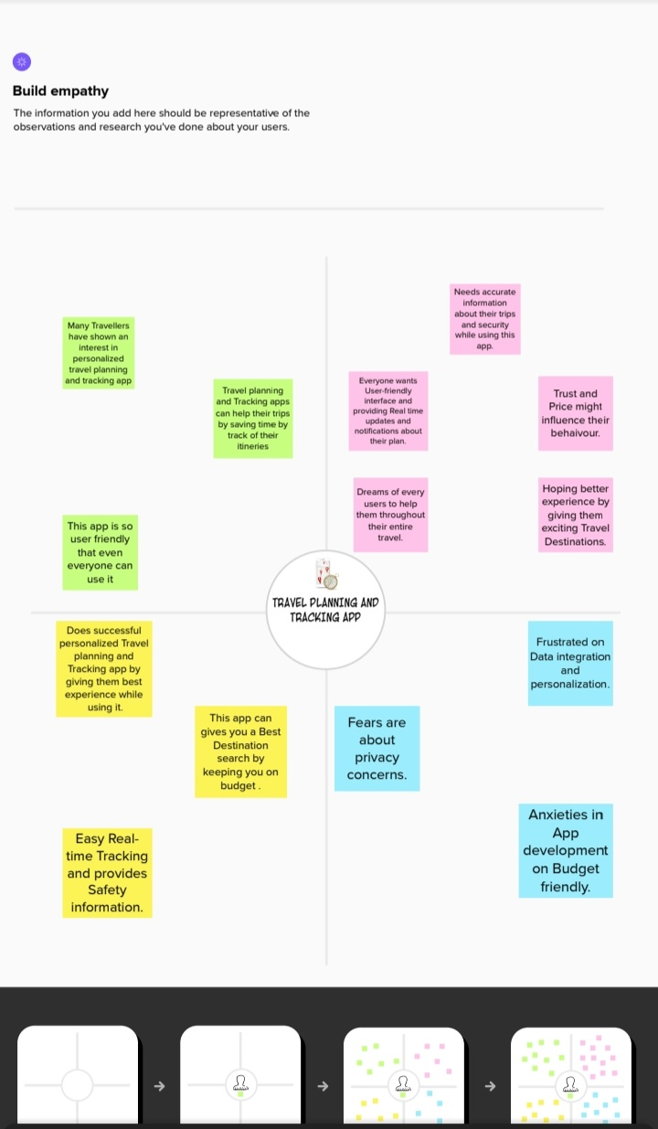

***2.2 BRAIN STORMING***

*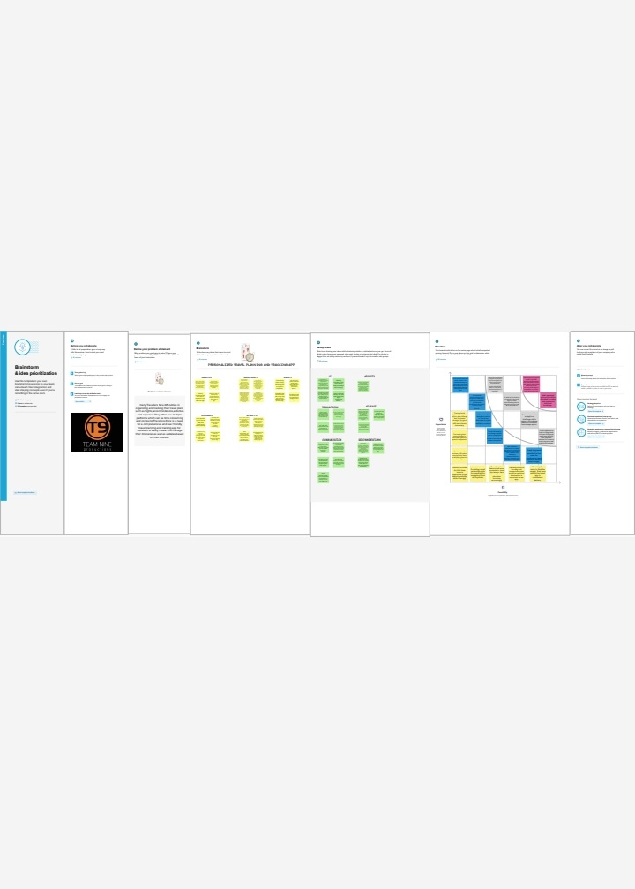****3. RESULT***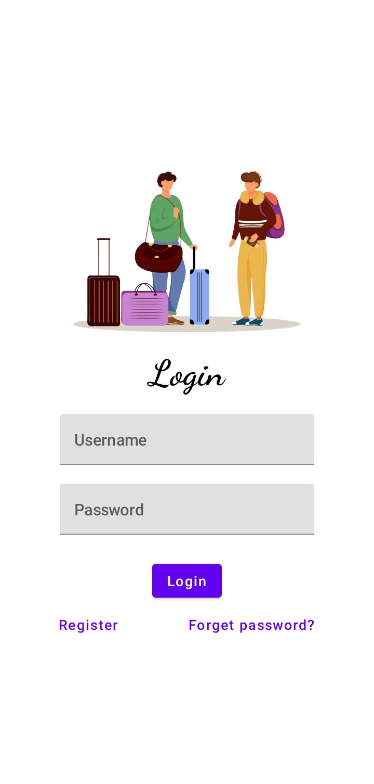

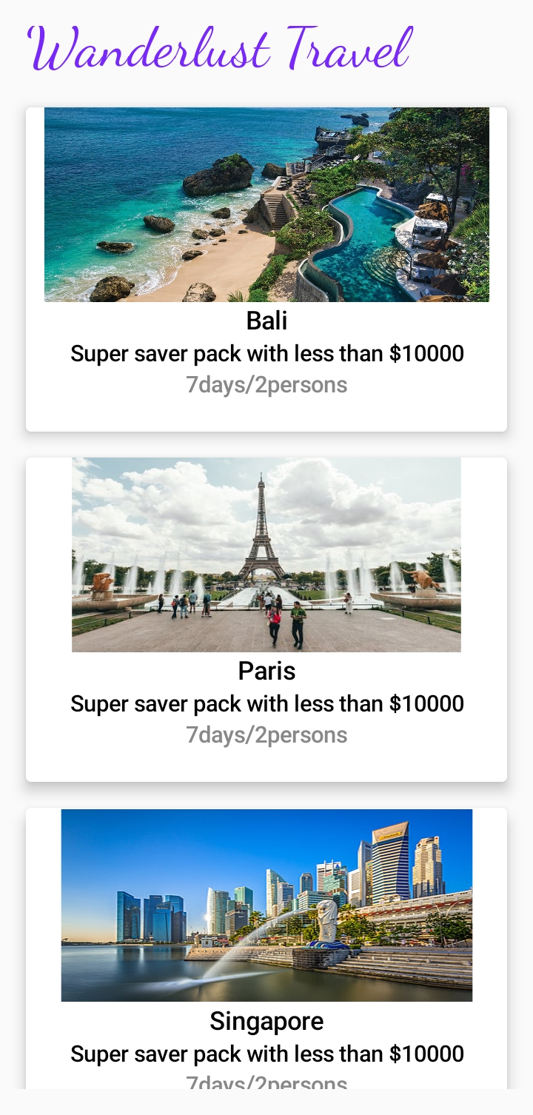

***4.ADVANTAGE AND DISADVANTAGE***

***4.1 ADVANTAGES***

< Organized Trip Planning

< Time and Cost Savings

< Real-Time update and notification

< Safety and Security

< Travel Tips and Guides

< User Friendly

***4.2 DISADVANTAGES***

> Technical issues

> Bad Internet Connectivity

> Specific Limitations

> Lack of Human Touch

> Improper Server Maintenance

***5.APPLICATIONS***

***INDIVIDUAL TRAVEL PLANNING:***

Travel Planning apps can be used by individual travelers to plan their trips, including Booking flights, Accommodations and activities.

***GROUP TRAVEL PLANNING:***

Travel Planning apps can be used by Group Travelers such as Families, Friends, or Corporate Teams to plan their Trips.

***BUSINESS TRAVEL MANAGEMENT:***

Businesses to manage their employees Business travel, including Booking flights, Hotels and Ground Transportation.

***6.CONCLUSION***

In conclusion, future travel planning and tracking apps can offer personalized recommendations, real-time updates, AR features, sustainable travel options, enhanced payment and booking options, social integration, AI chatbots, health and safety features, seamless multi-modal travel, and AI-driven personalization. These enhancements can revolutionize the way travelers plan and experience their trips, making travel more convenient, efficient, and tailored to individual preferences while keeping up with evolving travel trends and technologies.

***7.FUTURE SCOPE***

In future, travel planning and tracking apps can be enhanced through personalized recommendations, real-time updates, augmented reality (AR) features, sustainable travel options, advanced payment and booking options, social integration, AI-powered chatbots, health and safety features, seamless multi-modal travel, and AI-driven personalization. These enhancements can transform the travel experience by providing tailored and convenient features to meet the evolving needs and preferences of travelers.

***8.APPENDIX***

1. ***SOURCE CODE***

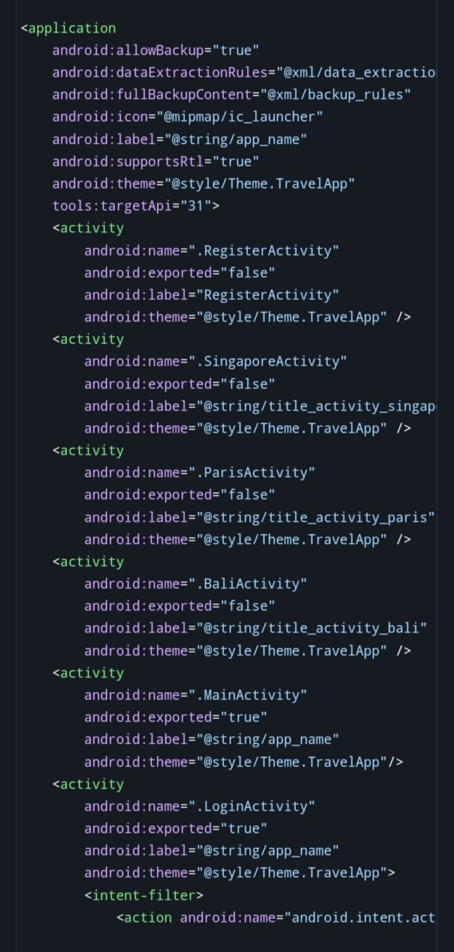

***TRAVEL PLANNING AND TRACKING APP PROJECT REPORTED BY***

***TEAM 9…***

***1. RAKSHITH.K [TEAM LEADER]***

***2. BAGAVATHRAM.C***

***3. SANJAI.K***

***4. SUDALESAN.R***

***5. NATARAJ. D. R***